Junction Object:
- Salesforce allows the use of Junction Objects which enables many-to-many relationships. Junction Object is a type of custom object which allows linking one custom object or one custom instance to many children records and each child can equally be linked to many parents.
- It is a custom object with two master details.

Example for Junction Object:
- Let consider first we create Project as custom object.
- Again create another two custom objects as Employee and Project Task.
- After that create a Master Detail relation ship with Project and Employee
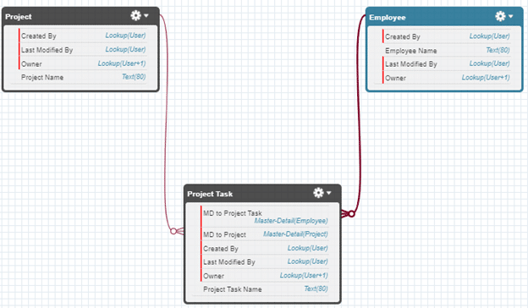

As another example for Junction Object as following,
- As we have to create Job recruiting Application, as we know position linked with many candidates and, candidate can apply to many positions. For that we required 3rd object as Job Application which linked with both.
- So we have to create a lookup field for both Position and Candidate object on the "Job Application" object. This will establish many to many relationship between Position and Candidate via the "Job Application" object known as the junction object.

